- \Operation\Carton Labeling\Printer
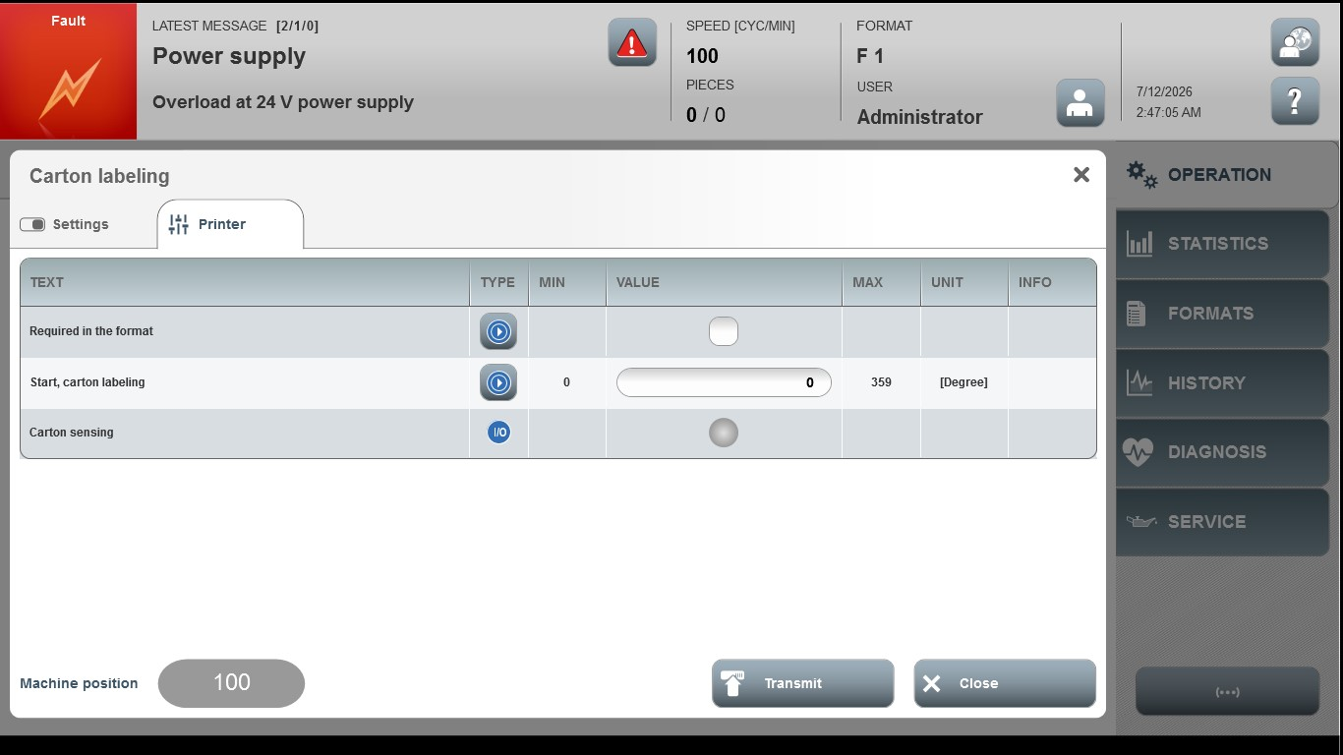

Acceptance criterion | Limits | Pass / Fail: Dev-No. | Date | Initials
Screen matches screenshot | N / A
Start,carton labeling | 0.00 … 359.00

